OFFICIAL COORDINATION REQUEST FOR
NON-ROUTINE OPERATIONS AND MAINTENANCE

COORDINATION TITLE – 15 LWG 025 Lower Granite JBS Primary Outfall Construction
COORDINATION DATE – 15 December 2015
PROJECT – Lower Granite Lock and Dam
RESPONSE DATE – 22 December 2015

Description of the problem: The Juvenile Bypass System (JBS) at Lower Granite Dam (LGR) is currently undergoing a variety of upgrades to improve downstream fish passage. As part of this upgrade project, the current primary bypass outfall is being replaced with a new outfall structure that will return downstream migrating fish to a new terminal location in the river. Additional time during the fall of 2016 is necessary to complete all in-water work activities associated with the installation of this new primary bypass outfall structure and subsequent removal of the existing outfall structures. To complete this bypass outfall work, the Corps proposes to conduct in-water construction activities in the LGR tailrace 15 November 2016 to 28 February 2017.

Type of outage required: The in-water work window will be extended to occur from 15 November 2016 to 28 February 2017 to support bypass outfall construction activities. No additional LGR facility outages will be required to support these construction activities beyond those previously coordinated through FPOM and FFRDWG (e.g. 13 LWG 17).

Impact on facility operation: Construction activities will occur in the LGR tailrace Boat Restricted Zone (BRZ) by a Corps contractor. Therefore, the contractor’s activities will be closely coordinated with LGR to ensure constructions activities are conducted safely in the BRZ.

The LGR JBS will be shut down 1 August 2016 to 24 March 2017, as previously coordinated with FPOM and FFDRWG, to support concrete mining of the collection channel and cross-over activities associated with tie-in of new project features to the JBS (13 LWG 17 Juvenile Fish Collection Channel Upgrade; 15 LWG 004 LWG JFF Construction). Per MOC “13 LWG 17 Juvenile Fish Collection Channel Upgrade”, the Corps will operate the RSW 12 hours per day (6 am to 6pm) from 1 September to 15 December. Changes to this RSW operation may be necessary to facilitate safe construction of the new primary bypass outfall in the LGR tailrace during this in-water work window.

Dates of impacts/repairs: The in-water work window will be extended by one month to occur from 15 November 2015 to 28 February 2017 to facilitate primary bypass outfall construction.

Length of time for repairs: It is anticipated that the in-water construction activities will occur from 15 November 2016 through February 2017. The new JBS features, including the new primary bypass outfall, will be commissioned in February-March 2017 to ensure the LGR JBS is operational prior to the 2017 fish passage season.

Expected impacts on fish passage: In-water work will primarily be conducted from a floating barge platform and limited distances from shore. As such, fish will be able to pass through the tailrace largely unobstructed during in-water work starting 15 November 2016.

Typically less than 30 chinook per day pass Lower Granite Dam starting 15 November. Up to 500 steelhead per day may be passing the project during this time period (Figure 2).
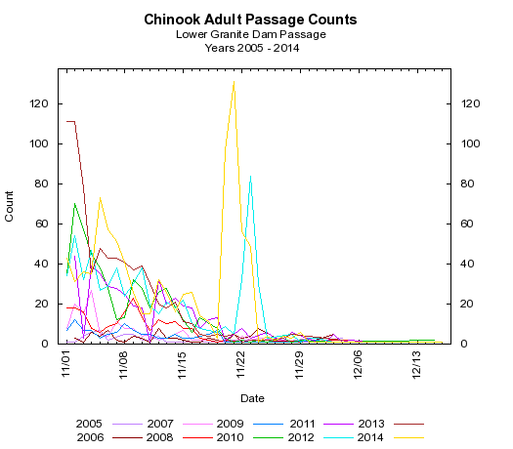

Figure 1. Adult Chinook passage counts for 2005-2014.

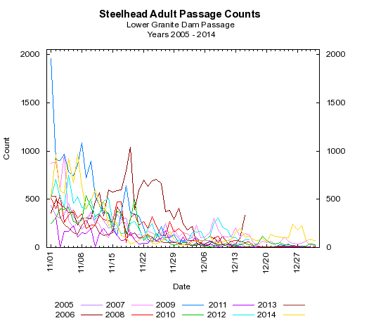
Figure 2. Adult steelhead passage counts for 2005-2014.

A known fall Chinook spawning area will be disturbed as part of constructing the new primary bypass outfall structure during this time period. It is possible that 5-10 fall chinook redds may be disturbed based on historical survey efforts (Figure 3). The shutdown of the JBS in August will reduce the likelihood of fall Chinook spawning in the area due to no water discharge from the JBS during the spawning period. As discussed at the 28 May 2015 NWW FFDRWG meeting, no new spawning surveys will be conducted as part of constructing the new primary bypass outfall.

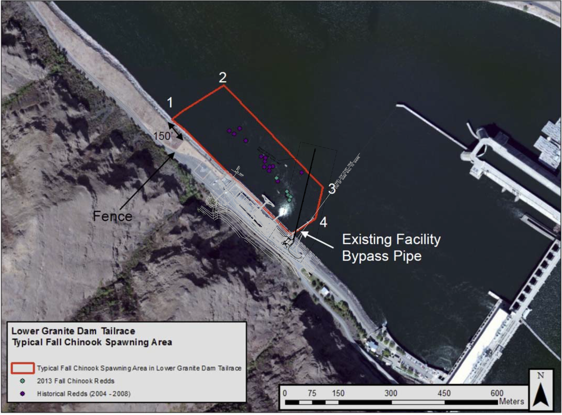
Figure 3. Typical fall Chinook spawning area in the Lower Granite Dam tailrace and new outfall construction area.

Comments from agencies

The proposed in-water work window of 15-November to 29 February was discussed at the NWW FFDRWG meeting 7 December 2015. NOAA and CRITFC indicated they were ok with the extended in-water work window for this primary bypass outfall construction project and that fall 2016 RSW operations could be modified or eliminated if necessary to facilitate successful completion of outfall construction activities. No other FFDRWG members provided feedback at the 7 December 2016 FFDRWG meeting.

The potential to disturb fall Chinook redds during in-water construction activities was discussed at NWW FFDRWG at the 28 May 2015 meeting. All participating fish managers including NOAA agreed to proceed with bypass outfall construction activities during the 2016/17 in-water work window without conducting additional spawning surveys or modifications to the new primary bypass outfall footprint.

Final results

David Trachtenbarg
Fish Biologist
Environmental Analysis Section
U.S. Army Corps of Engineers
Walla Walla District
201 N 3rd Ave.
Walla Walla, WA 99362
Phone: 509-527-7238

